Rakesh Shrestha
Module 1.3 Programming Assignment
September 13, 2026

Initial four cards
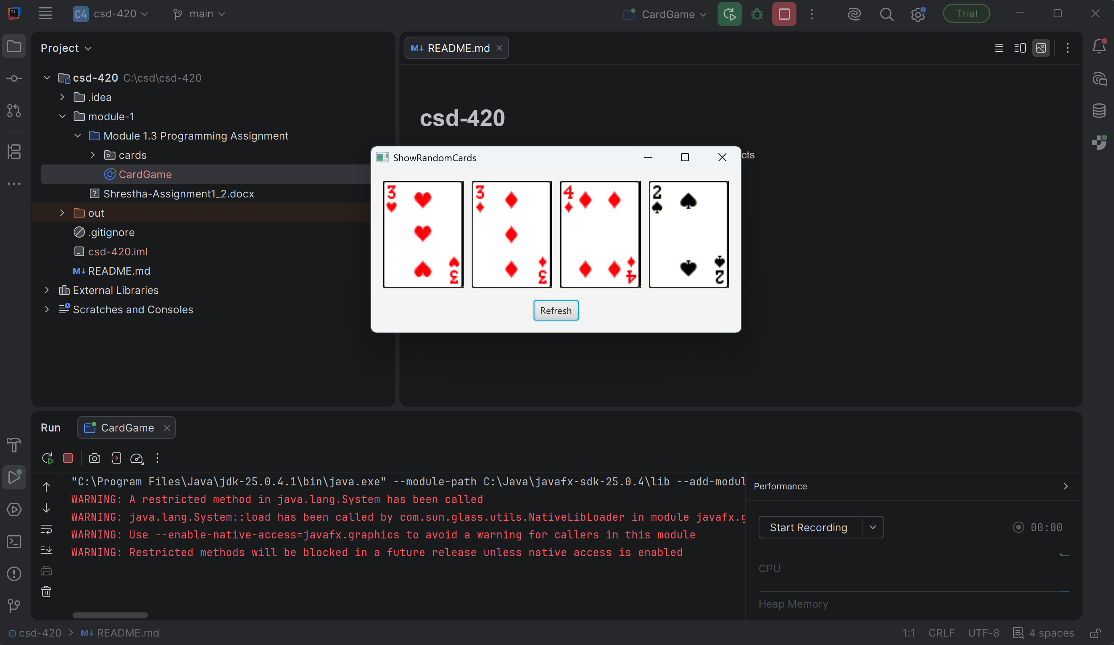
Refresh with new cards
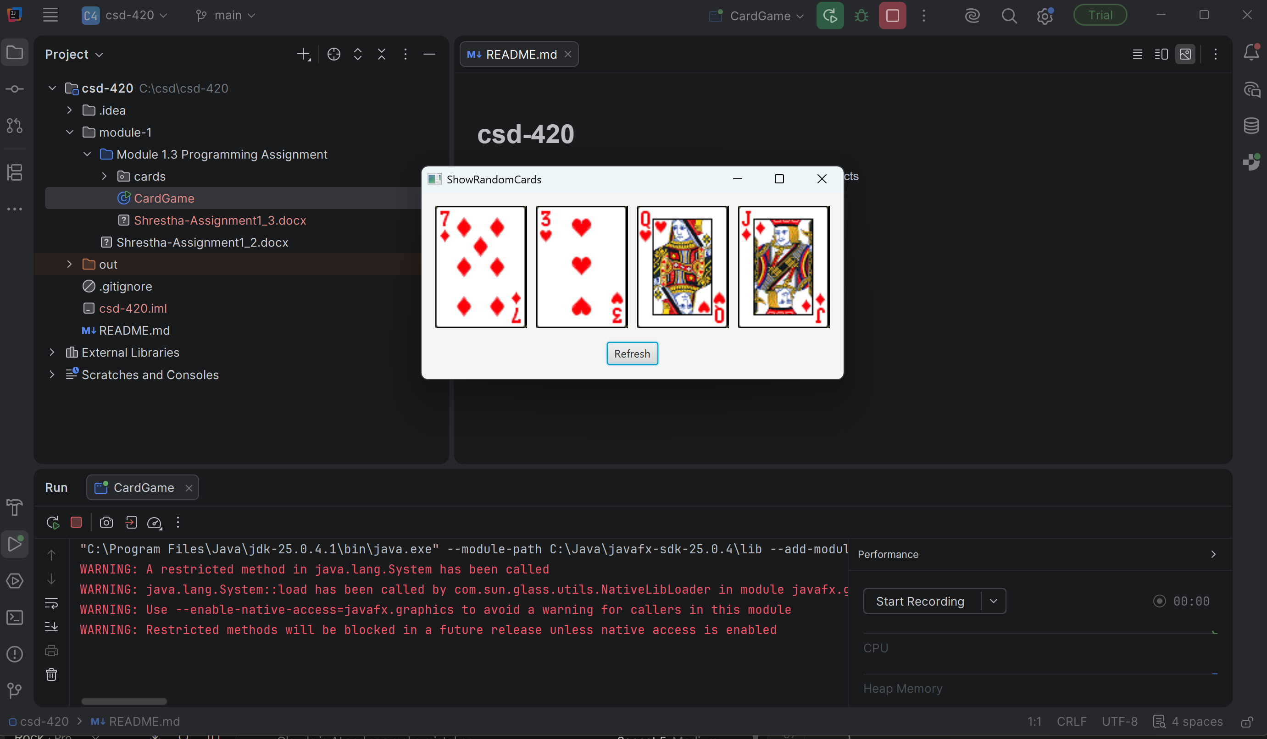
JavaFX SDK configured
